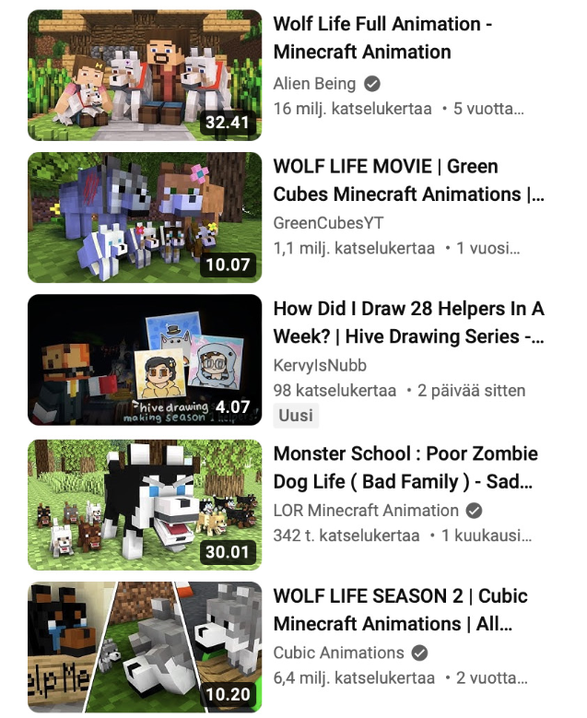
Impact of AI
1
Data
Mary likes to watch videos on YouTube.
- How does YouTube know to recommend exactly the type of videos that Mary is interested in?
(Write answer here)

- How can these recommendations affect Mary’s thinking and actions?
(Write answer here)

2
Bias
When creating a presentation about video games and gaming,students used AI image generator to generate pictures of children playing video games.

There was a problem: In these pictures, there were no girls.
- Why do you think this happened?
(Write answer here)

- What kind of issues might this cause?
(Write answer here)

3
Brittleness
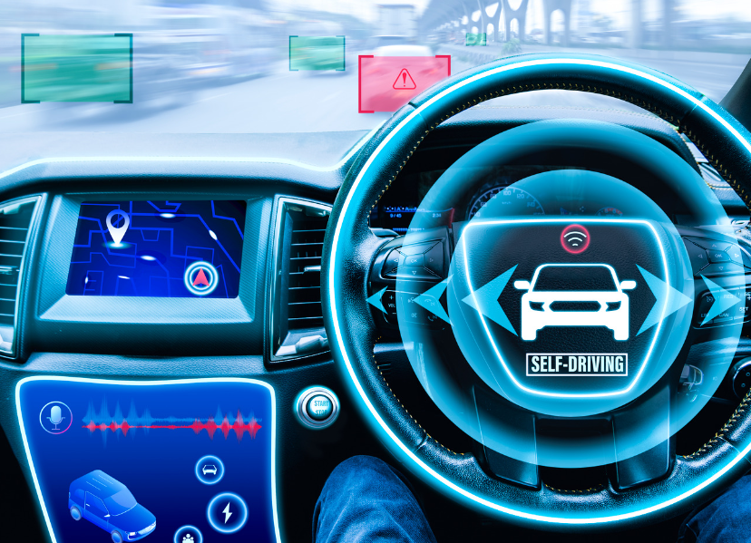
Italian engineers developed a machine vision system for cars. The training data was collected in Italia, France ja UK. When cars that were using this system were imported to Finland, they could not function properly.
- Why did the car fail in Finland?
(Write answer here)

- What could be the training data for machine vision system such as this?
(Write answer here)

