How does the social media machine make inferences?
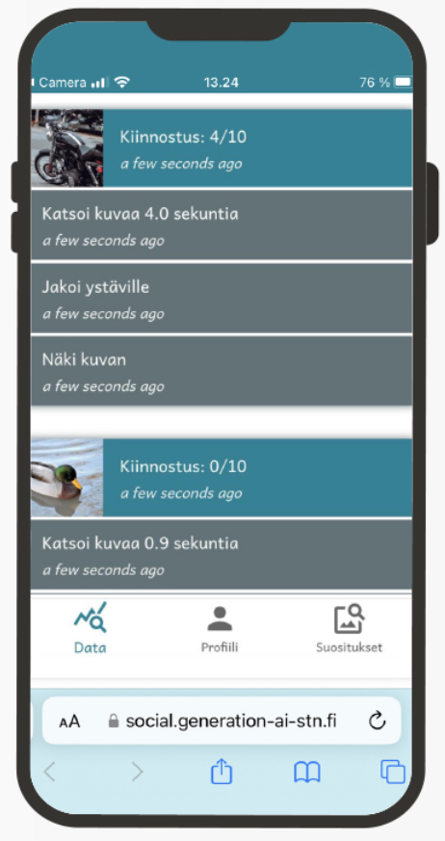
1
Browse the image feed. Find images that you like. Find out how the social media machine calculates the “activity score.”
- When is the score 0/10?
(Write down your answer)

- When is the score 10/10?
(Write down your answer)

- Which factors affect the scoring?
(Write down your answer)

Examining the profile
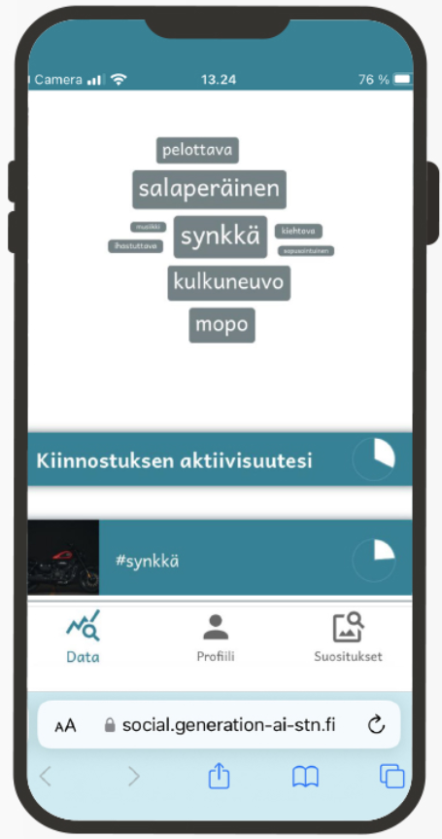
2
Open the ‘Profile’ page to see what kind of profile the social media machine has created about you.
- Which hashtags are included in the word cloud? On what grounds were they selected?
(Write down your answer)

- Explain what the social media machine got right and why.
(Write down your answer)

- What parts of the profiling failed? Why?
(Write down your answer)

Comparing profiles
3
Find your own profile on the teacher’s machine (the projector). Note whose profiles are closest to your own.
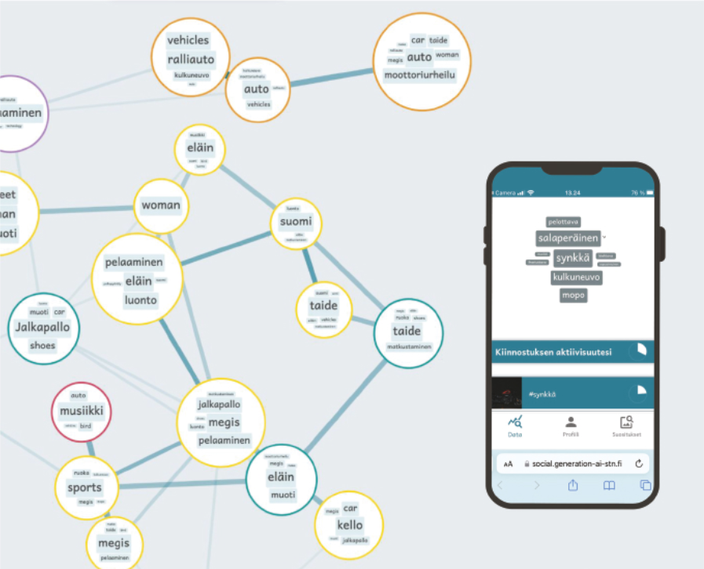
Why are they close to your profile?
(Write down your answer)

How does the Social media machine make recommendations?
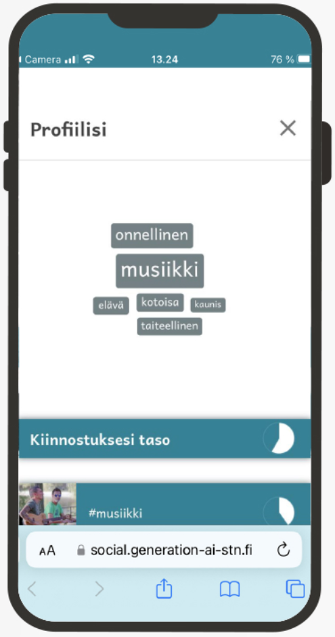
4
Look at the ‘Recommendations’ -tab of the social media machine.
On what basis does the social media machine choose images that interest you?
(Write down your answer)

