
The process of creating your AI classifier application

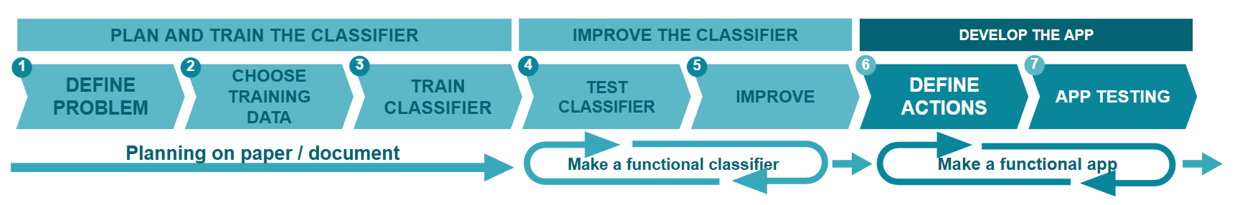
Plan and training the classifier
1
Define the problem
- What kind of problem does this app solve?
(Write your answer here)

- What things does the app recognise (classify)?
(Write your answer here)

2
Choose the training data
- How many classes do you need for the classifier?
(Write your answer here)

- Where can you find the training data for the classifier?
(Write your answer here)

3
Train the classifier
- In what conditions does the classifier have to work in?
(Write your answer here)

- How do you you make sure the training data is of good quality and there is enough training data?
(Write your answer here)

Improve the classifier
4
Test the classifier
- How well does your classifier work?
(Write your answer here)

- How certain is the classifier in cases where you test it with data that is not included in the training data?
(Write your answer here)

5
Improve
- In which situations the classifier works well? Why?
(Write your answer here)

- How do you intend to improve the classifier?
(Write your answer here)

Develop the app

Define actions
6
What kind of actions do you want the app to perform when it recognises a class?
(Write your answer here)

7
App testing
Does the app work as intended? How can you further improve it?
(Write your answer here)

