1
- Check the boxers next to the apps that you use regularly (daily or couple of times a week).
- Click the boxes in the right column if you believe that AI systems are controlling some aspects of the app
- Compare the results with a pair or in small groups.
App |  | I use regularly | AI systems involved?
 | YouTube
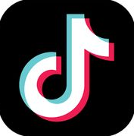 | TikTok
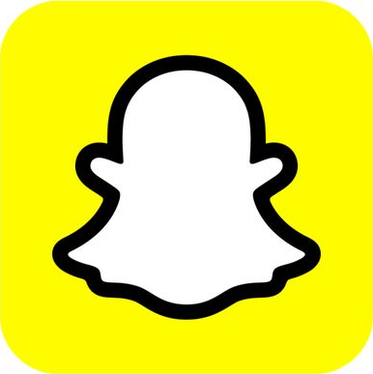 | Snapchat
 | Instagram
 | Facebook
 | X
 | WhatsApp
 | Signal
 | Discord
 | Spotify
 | Tumblr
↑ You can add more apps you use on the last two rows ↑
2
Choose one app that utilises AI.
- What’s the name of the app?
(Write answer here)

- What kind of data does this app collect of you?
(Write answer here)

- How is this data used?
(Write answer here)

- What risks do you recognise in collection of this data?
(Write answer here)

